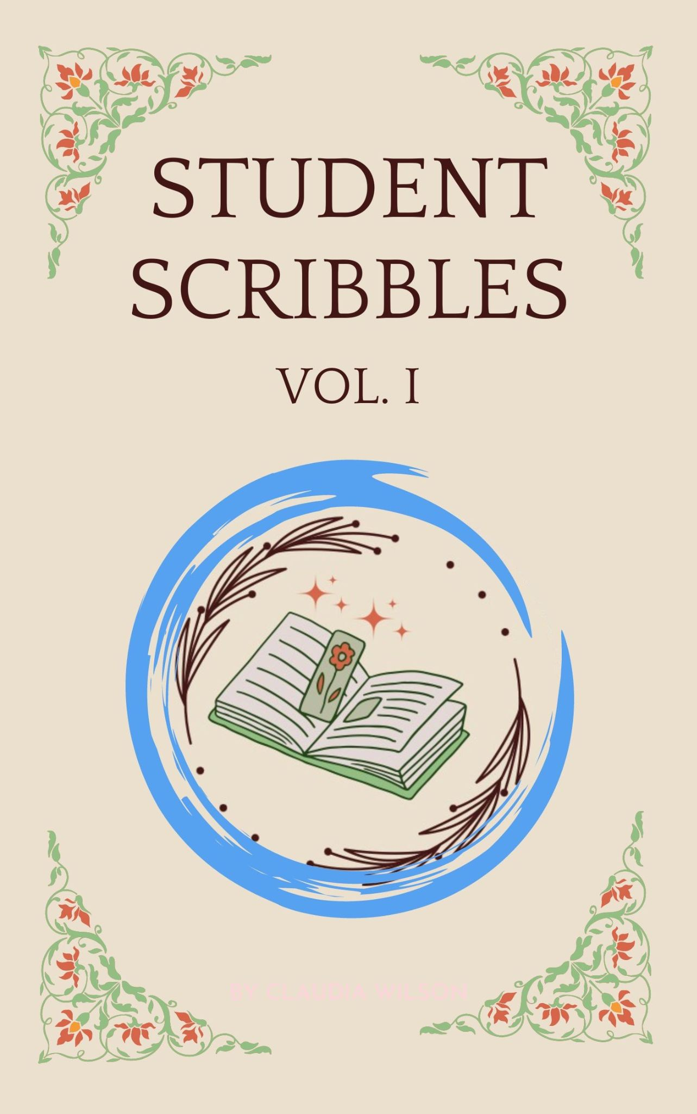

Student Scribbles vol. 1
The Scribble Society’s publication.
Liverpool Hope University
Released 18th May 2024
In support of LDAS
Cover design by Charlotte Goddard

Student Scribbles
vol. 1

About Us
The Scribble Society was founded in 2023 at Liverpool Hope University. We are dedicated to connecting students together and being a creative safe space. Our members include all types of creative minds, from writers to artists. The Scribble Society’s goal is to have our members working collaboratively across a wide variety of mediums in a safe space that focuses on its members’ artistic development.
The aim of the society was to publish a collective work including creative pieces from our members to give them a taste of what it is like to be published and the process this involves. This book is that dream come to life. It includes written works; from fiction, creative non-fiction and poetry. As well as a selected array of art pieces. Everything you are about to experience is the product of a year-long journey that the Scribble Society has undertaken.
One of the main reasons we wanted to create this book was to give back to the community, this is why all the profits of the book will be given to a charity. Our members chose a charity that they wanted to support. You can find more information about this charity below.
The leadership team of the Scribble Society welcomes you to our little masterpiece and look forward to many more years of supporting creative minds.

About LDAS
The Liverpool Domestic Abuse Service (LDAS) is a Liverpool based charity and was chosen by our members to support with the profits from the book. They aim to assist, protect and empower women and girls to live safe and independent lives free from domestic abuse. We would like to thank them for everything they do and letting us help them to get closer to their goal. If you would like to learn more about the LDAS you can visit their website: https://liverpooldomesticabuseservice.org.uk/

Contents
Title of piece Page
Growing Up 7-9
The Man in the Periphery 10-12
Piece One from Flowers & Decay 15
Containment 16
Children By The Sea 17-18
The Untold Story of Jack Tate 19
The Watcher 20-22
Demon 23
Warmth 24-25
The Soulflare Tome-Ar 26-28
Untitled 29
For Arthur 30-34
Knight 35
Love after Loss 36
A Change Constant 37-45
Piece Two from Flowers & Decay 46
Trainwreck 47-49
The Meet Cute 50-51
Factory 52-54
When Is Rotten? 55
Nausicaa by the Shore 56-60
To Be Loved By Me 61
Piece Three from Flowers & Decay 62

Growing Up
By Matthew Southam
Life is a very peculiar thing. So peculiar in fact, that we spend most of our time trying not to think about it. The grand indifference of an infinite universe. Vincent Van Gogh once wrote, “For my part I know nothing with any certainty, but the sight of the stars makes me dream” [1]. A beautiful idea, to stare the abyss in the face and be inspired. To reach for the stars without knowing how. To dream. Through that idea, we find purpose and meaning in our lives. The only problem is: what should be the dream?
I’m sure like most of you, I spent my late teens and early twenties trying to figure out what the dream was. What do I want to do with my life? It just never seemed clear to me. Even now as I write this I still don’t know what I’m striving for. For a long time, I searched for meaning in my life, often finding an empty bottle of beer filled with fag butts. I worked a few jobs here and there, studied a bit but nothing that screamed ‘This is it!’ I started to wonder if I even had an ‘it’ and that horrified me. I remember the day it hit me. My 23rd birthday. Surrounded by all my friends and family, in the middle of a music festival. I cried into my vodka orange. The indifference was too overwhelming for me but I kept searching. Not long after, in a spurt of existential dread, I began to write fully formed, angry tomes in an attempt to find some kind of answer in the chaos. This was a hard time in my life.
When you decide to take control of your life, it's like dying. Everything you once were is now gone. The people you knew become strangers. The life you had gets totally flipped around and your new life feels like it isn't yours. Now I’m embarrassed by all the references to suicide in my earliest work, but I understand why. I did kill myself, or what I saw myself as at the time. Through all of this self analysis and change, I was still searching for purpose but now I had pen and paper on my side. Loyld Alexander once said "fantasy is hardly an escape from reality, it's a way of understanding it" [2] and over the next few years my pen would guide me on my search for purpose.
I fell into writing like landing on the bottom step of some icy stairs. It hurt to get there but it stopped me from falling further. All the ideas I wanted to explore about myself and the world around me could now be set free. My

pen now a torch lighting the way. There is a Charles Bukowski poem called "so you want to be a writer?", which I would highly recommend for any aspiring writers, that discusses what it means to become a writer. In the poem, Bukowski writes "When it is time, and you have been chosen, it will do it by itself" [3] which was and still is the case for me. I had to write so I could find purpose. Through the reading and perfecting of my own words; between the punctuation and rhyme, the damsel and trickster, I looked for something, anything that I could grab and call mine. This hunger had me writing constantly in the beginning. Mostly the same old angsty spoken word you hear at every open mic but, little by little, I felt myself change.
Finally, I started to see myself for who I really was. A lost child, searching for their mother, grabbing onto anything and everything that wasn’t indifferent to me. Instead of marvelling at the majesty of existence, I was rapidly analysing it expecting an answer, in fact demanding one. The funny thing is that if you asked me now what the dream is, I could list you 20. New ones come to me all the time. Will I do them? Hopefully. The point is in all the searching; the bad habits, friends and situations I put myself in, I missed what was staring me right in the face. All the things that give my life meaning have come to me when I needed them most. Like writing. Like music. Like love. These things aren’t dreams but they are what dreams are made of. My pen wasn’t a torch but a lighthouse, guiding dreams onto paper. If you’re a writer, artist, musician, creative and don’t know what to do with your skill, don’t worry. Keep honing your craft and eventually a dream will come and find you.

Come and Find Me
Around some corner there must be more;
Down a long lost alleyway, wet and cobbled green moss,
Down the overgrown ginnel you’re too scared to walk at night;
In that field; under the distant, solitary tree, there must be more.
In the friendships time and place have stolen from you;
In cold winter nights, in the snowdrift on the hill,
In the homes you've never lived, in the dark behind the decorations in the attic,
In the awe inspiring views I've missed, there must be more.
Before I knew me, before the curtain call,
There must be more.
In the hearts left cold and untouched,
There must be more.
In the wide eyes of those who seek,
There must be more.
In the consuming incompleteness I've felt before,
There must be more...
I have searched for, and shall search nevermore;
Come and find me.
If you enjoyed the poem, go and check out my Instagram page @thesubconsciouswriter. I post most of my work there.
[1] On Verticality. (n.d.). ‘For my part I know nothing with any certainty, but the sight of the stars makes me dream.’ [online] Available at: https://www.onverticality.com/blog/van-gogh-quote.
[2] ‌www.youtube.com. (n.d.). Lloyd Alexander (part 2 of 3). [online] Available at: https://www.youtube.com/watch?v=GilIovrb4uE&t=343s [Accessed 21 Mar. 2024].
[3] Academy of American Poets (2019). so you want to be a writer? by Charles Bukowski - Poems | poets.org. [online] Poets.org. Available at: https://poets.org/poem/so-you-want-be-writer.

The Man in the Periphery
By Salis Fern
Every sight was something to behold. Condensation on glass surfaces, shadows flickering in candlelight, tea rings left by overfull mugs. Every speck of the world could be viewed through a biological lens we have naturally. All the dazzling lights of human creation formatting the world into a scene worth opening your eyes for.
Yet the lens we seek is not always one framed in beauty. Sometimes those flickering shadows can creep and crawl beside you, curling beneath your feet as you tread, your vision faced away from all that is behind you. Just out of sight. The edges of the world. Perceived on a daily basis but made up by the falsity of the mind. Filling in details you will always believe were real. A merging of truth and reality blended so seamlessly that no difference could ever be told.
Occasionally a crack will form, a glitch in the processing, a mistake in the patterning.
An unknown shape in the periphery.
-0-
Sally had finished her work that hapless day. The winter’s night crept closer and the darkness would loom ever earlier over the little town of Glooms-Creek. Her quaint bakery was tucked away on a pleasant, cobbled street just off the main thoroughfare and was, to the behest of the customers, closing for the day. Having to wait another day for her award-winning banana bread.
A jingle rang through the street as the small bell above her door rang for the last time as she locked up. The key struggling in the lock, it had become sticky of late, as if the door wanted to remain eternally open. Falling to the ground in a stubborn resistance, Sally was forced to lean over and pick it up from where it lay nestled in the broken cobbles.
Leaning down the lamppost nearby flickered in response, its light waning for a few long seconds before striving to return. In a flash, Sally could see

a figure of what she could only describe as a person standing to her right, just at the edge of her vision. Barely even there. She twisted her full attention to the figure, forgoing the key. Nothing. Not even a familiar shadow. She blinked slowly, tired, her eyes must have been heavy. Reaching down once more she snapped the key up with an alerted haste and hurriedly locked the door before spinning in place and beginning her deceptively long walk home.
Everything seemed normal. The teens on the corner were still loitering, Old Tim was still trimming his hedge. Even the dilapidated building lay desolate, its wall’s whistling as wind whips through the myriad of holes scattering the exterior. Sally’s gaze had only fleetingly glanced through one of the medium sized gaps. Yet stood there once more as the ‘figure’ of a person, its mass coalesced into a mockery of human form. She couldn't be sure, as when she focused her gaze it dissipated, as if its presence was never known. Only now it appeared closer than before. Sally’s heart rate rose, her steps echoed louder as she dropped her earlier nonchalance and moved at a heightened pace.
Sally had lived in Gloom Creek for a few years now, she wasn’t exactly a local, but she had been around the block a few times. Despite that she was still unsettled, the late-night customers whispered often of generational folktales, some they shared, some they didn't. She was warned often not to think too deeply about them lest she blur reality with fabrications of the mind.
Especially since the warning had come from Madam Grinsel, local crazy. Rumours stated that she encountered a ‘serendipitous horror’, one that made her eye glaze over and iris shatter. Her mind forever fractured. Everyone knew it. That’s what they said, it’s not how they acted. Her words were an unholy gospel. The looks she received by customers when cautioned by the madam, had made her stomach twist in impossible knots.
‘Real horrors lurk in the places we only seek on accident. They blend their presence with our own, conforming to the delusions created by our own minds. I wonder dear…. Who lurks beyond your sight?’
Who would believe that? She had thought. Paying it no attention she had continued with her day. Her week. Until now.
Now it swarmed her mind as she moved as quickly as socially acceptable through the once picturesque town which was now warped by lurking shadows and colourful nightmares. The mannequins looked animate, the

bookstore turned gloomy, an endless abyss of words emerging to taunt her. The playground creaked with rust, the swings squeaking faintly as they were pushed by the insolent wind.
Silence. The swing had stopped. Once more the ‘figure’ had appeared only to stop the swing from its incessant noise. Sally’s heart stopped. This time she wouldn’t look; wouldn’t make it real.
Memories of childhood crowded her mind, ones she thought were lost deep in the crevices of her mind. Images of her cowering behind her mother, ducking behind trees, hiding under tables to escape the shape. The shape that followed her through life. It had always been present, beside her, just out of reach. Skulking at the edges of her vision, like a stain on the corner of a masterpiece.
Where had it gone all this time, had she simply stopped believing in it? Cast it from her mind? The memory that mattered most, its disappearance, was no longer a part of her. For it was back. Back at her side one more.
Close now, she was almost home. Clutching onto the childish wish that this was all Sally’s imagination playing tricks on her; that once she was home out of the strange streets of Glooms-Creek she would once again be safe.
It was watching her. Just as she would watch it. Her eyes looking forward, yet her attention is only on the outskirts of her vision. That’s where she could see it. Always skirting around staying out of her direct sight. Playing games. Perhaps if she was younger and fearless, she could have played hide and seek with the shape. Was that what it wanted? Someone to play with? Her once hastened footsteps slowing down as her mind turned. Why did it follow her?
Moments now from her front door, she came to a standstill at the end of the street. Her door illuminated by a beautiful warm orange glow; flowers grew from hanging baskets in luscious bright colours. The vibrancy of the red door stood out even when the clouds would cover the moon. This was her house, her safe haven. Yet she paused a metre away. Sally’s mind ablaze with the shadows that lurked behind her, their tendrils reaching out. She looked behind her. The street covered, swirling with a dark mist; the lights had gone out from whence she came. A gust of wind blew the hair from her face as she slowly moved the rest of her body to look back. Again, the mists began to coalesce and swirl in an unnaturally inviting gesture. The maw of a black opaque mass seemed to appear; its teeth

made of ghastly eyes consisting only of madness behind them. Lurking and watching from beyond her own vision. The shape had appeared.
Familiar even in its ungodly visage, its sight a writhing mass of lurking nightmares, made of her childhood delusions. Her own demise fabricated into the form before her. She should be screaming, terrified.
Sally could not look away.
Her own eyes unblinking as she stared motionlessly at the visage enraptured by its coiling and curling motions, the form was lost on her as it flickered, changing before her. Into the shape that followed her from childhood. That friendly, lovely shape. Always beside her, in her periphery. Sally’s consciousness blended with the horror before her. Reality and fabrication seamlessly becoming one. She accepted the shape as her reality.
Home was no longer behind her; it was before her. The shape no longer was her periphery, it was her everything. Her entire world was envisioned right in front. Sally took a hesitant step forward, then another and another. The coiling filaments of slick smoke enveloped the space around her filling her vision, entering through the crack she made between her and beyond.
The man in the periphery had welcomed her in.
-0-
The next day she reappeared as normal heading to work with a joyful smile and skip in her step. The townsfolk watched hesitantly as she opened her bakery, the key gliding through the lock with ease. The smell of banana bread, enticing even those who wouldn’t dare enter the store to look. She lured them in and sold them delicacies. Each customer with a hesitant step would enter and leave with an unsettling feeling crawling up their back.
Sally would smile and wave them goodbye as they left. She wondered why no one looked her in the eyes anymore. Everything was so very beautiful. Glancing out the window, the reflection of her form was visible.

All in place. Even the lovely vacuous empty spaces where her eyes used to be. Filled only with that same coiling maw that had enveloped her.
The townsfolk couldn’t see her.
Until they saw her through their periphery.
There she lurked at the edges of their vision.
A horror they would see on accident.

The End.

Piece One from Flowers & Decay
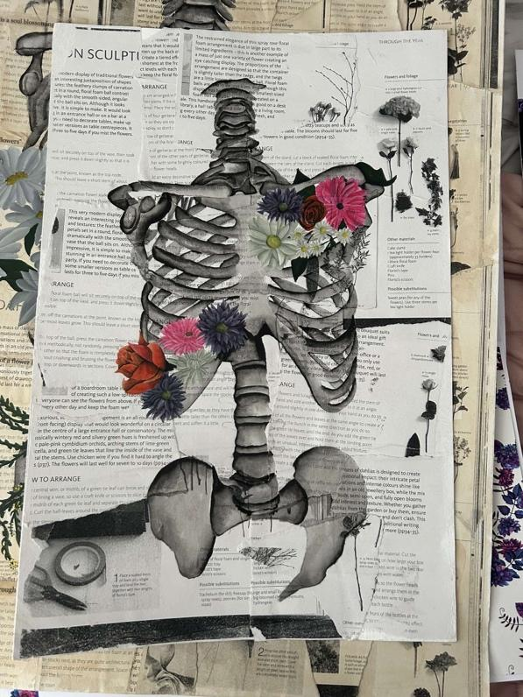
By Charlotte Goddard

Containment
By Eden Wallis
The light, the noise, the smell,
the dark shadow that looms in the corner.
Walk. WALK to the group that huddles.
Freeze. Constricted throat and damaged lungs,
their piercing eyes expose your soul.
Breath stolen to be kept in a jar
the high shelf you struggle to reach,
it tips, it falls, it smashes.
Slam the door, lock the feelings, swallow the key.
Choke. The hand holds your throat, burning skin.
Pacing feet, imprints in the carpet,
Fidgeting hands which soon settle.
Closed mind, slowed heart rate.
Silence, Darkness. The bed pulls you in.
Comfort… the duvet buttons you up
keeping away the panic, keeping away the whispers,
a heartbeat settles, too restless in sleep
escape to a dream, where daylight drags you to the moon
as you stare down at earth, a million miles away where
quiet can only be heard.

Children By The Sea
By Jacob Routledge
A road ran away from a hill towards a teal sea. It was filled with tiny feet and the occasional quartet of rubber wheels. The feet belonged to displaced children, and they meandered in a macabre trance. The road out of town was busy. The children were evacuating; the war had reached England’s shores. Nobody knew how long the evacuation would last for. The crisis however was given no breath in the chatter that littered the magical evening air. Across the teal sea, according to some of the children, there is a part of Fristland that exists in perpetual blueness. All the cafés and all the men and all the dogs and all the gardens are blue. There is even a blue castle! In this special part of Fristland, one of the children said, everything exists in calmness and serenity. There is no such thing as a bad word.
“A castle!” exclaimed Clarence, who had been listening to this tale with some frustration. He was exasperated far beyond his years. A good English lad.
“Maybe they mean the Newheath Newsagent at the top of the hill,” replied Phillip.
“Best shop in Fristland” he added.
Phillip had been to Fristland and believed everything to be blue there. He possessed a precocious knowledge of places and things. His father had been a courier before the war and would take Phillip along with him on long journeys. His father was wounded in Holland at this very moment. He had been shot in battle. He would probably die.
Clarence and Phillip belonged to the herd of children escaping down the road towards the sea. Eventually, they would all reach the shore and discover the boats sent to rescue them had been delayed. By the time Walter’s voice was heard, the children had cleared the hill and had begun congregating on the shore in their assigned groups. He was carrying no possessions. He was not lumbered with sentimentality like the others. Walter also stood out because his only friends were girls. There were no boys or men around him. Even his guides, who had been sent from

Fristland to escort the children, were females. In this group of women, he felt he had to say something. He had the urge to make a move.
“I’d say that everyone is created equal and that from birth everybody should be given the exact same chances and opportunities as everyone else” he squeaked to his friends. He was nine years old which made him the oldest child on the shore.
After some deliberation between the guides, it was agreed that group should wait for the ships. After all, the Fristegese had promised they would rescue them and what reason did they have to lie? Personal gain would ensure mutual destruction; this was understood. The ships did come, one more than promised, and the tiny feet left the shore and the road and the hill behind them. Somewhere a blue man put down his pen.

The Untold Story of Jack Tate
By Star Jones
Tony, the sign reads, the blue jay said in his lilted whistle.
Not Our Tony? I hoped, so asked the bird if the last name’s Tate.
Before he had chance to chirp, the crunch of gravel scared him away:
a small crowd of youths dressed mostly in grey
staggered through our lynch gate.
The life that spread across their face shot me with jealousy’s pistol,
as they window shopped for a gruesome tale.
As they made their rounds, sympathies stumbled from their mouths.
They said Rob didn’t deserve what got put in his lungs in ‘18.
It wasn’t fair that Fred accidentally ate a poison berry in ’64.
It wasn’t Stanley’s time when he sped over his car in ’63.
It shouldn’t have come to Susan choosing rope for pearls in ’24.
It was such a shame that Donald got into that fight in ’79.
But when they came to me, not a sound.
Damp had mildewed the words on the sign on top of me,
so they couldn’t see my story.
What the words once told, those grey youngers will never know:
how or where or when I got here, beside Fred and Donald.
They didn’t try to squint or get a closer look,
the small crowd of youths dressed mostly in grey
just moved on to the next, like I was a poorly covered book.
When the blue jay returned, he had some information on Tony:
he wasn’t a Tate but an Anderson.
That name had caught me once, walking home from the flower shop.
He had put his shank in me because he thought I left him no money.
What he didn’t know: I left it on the counter with change, in a hurry.
What the grey youths didn’t know is Tony is where he ought to be for stealing Jack from his wife and their unborn baby.

The Watcher
By Lucy Radcliffe
There’s a couple in front of me, exchanging numbers. Giggling and shivering. The rain had swept across the auburn park out of nowhere - cutting their first date short. One had black hair and one had blonde hair, a perfect match. They awkwardly hug, their damp clothes squelch between them. They begin walking away but soon realise they’re going in the same direction. They laugh and continue to talk as they exit the park. My eyes follow the two women as they leave, wind blowing their hair in all directions and rain splattering across my glasses - blurring my vision.
A man in a suit walked by - soaked. In one hand he held a leather briefcase, in the other he held a broken umbrella. I almost felt bad, but the lines on his face informed me of his corrupt corporate past. Opted not to give him my umbrella. The rain was slapping me across the face - coming in fast at a slant. But I held my pug-patterned umbrella upright. I’m not made of sugar.
Someone ran by with a guitar case hugged to their chest. I hardly caught a glimpse of them. I hope their instrument is okay.
An elderly pair shuffled through the park - I saw them enter a few hours ago with a loaf of bread, now they were leaving with just the heel slices. The man, with his whiskers and wisps of thin hair, had an arm around his tiny, hunched wife. His coat clung to the shoulders of her slim frame and they fought against the weather to return to the safety of their home.
A group of students leave with their blue plastic bags of alcohol. Clearly their evening plans have been ruined. In my day, we stuck out the rain. Purely in fear of being caught drinking.
I noticed a trio of pigeons hiding under a bench opposite me. Huddling together for any kind of warmth. Their feathers were damp and heavy. Droplets of the rain slipped through the gaps of the wood - Pigeons are too dumb to know the difference though. A shaggy young man walked by and left a sheet of cardboard over them. Providing a proper ceiling. The cardboard said; “£40 and I can spend a night in a hostel”. I hope he got that 40.
I spotted a mother across the way - a toddler and a pram. She struggled to yank the plastic rain cover over her baby while also holding onto the

back-pack lead that heer toddler was tied down to. He was crying at the clouds above - perhaps cursing them for ruining his trip to the playground. She eventually got the cover on and she pulled her son's hood up before tugging her own on. She pushed the pram with one hand and dragged the little boy after her. I wondered - where was her partner? She had a wedding band.
A father called to his daughter not to jump in the growing puddle that formed in the divot by the fountain. She hesitated at the water edge - raindrops fell into it and rippled outwards. She was wearing ballet slipper shoes and a pair of white socks. She jumped. She ruined her socks. Her father carried her to their car, but he wasn’t mad.
I saw a couple walking their dog out of the park. The tall man was covered in muck as if he had done a slip n slide down a hill belly first. But then I saw the dog. I think it was meant to be a golden retriever. I pray for the wellbeing of their back seats.
A woman was twirling under her husband's arm. They had no coats. Water dripped from both their hairs but I don’t think they actually cared. Her summer red dress was like wet cement against her skin and his white shirt was practically see through from the dampness. They danced for a while, kissed once, then twice, and probably a few more times. I think they’re soulmates. They left with smiles.
There were two little boys, walking in front of their guardian as they left. Slowly. Did they realise it was pouring down? They were too busy pointing at the leaves above them, counting how many were left on the tree tops. It even made me look to count. I lost track after 72.
I heard a man telling his teenage son; “Better luck next time” as they left. They had thick green welly boots on and a fishing rod each over their shoulders. I forgot there was a lake in this park. Won’t it be frozen soon?
There was an old man. He was walking with his hands behind his back. His farmer cap kept the rain out of his eyes. He wandered by like a zombie - unrushed and bored. I felt bad for him. He looked very sad. I wondered if he too was as lonely as I, perhaps I should’ve invited him over to watch the others around us. Instead I only smiled at him and he smiled soberly back.
Although I only saw a glimpse into their lives I feel as though I cannot call them strangers. The memory of them sticks with me, their faces and

expressions etched into this writing. I hope each of them went home after that rainy day and smiled at something, I hope they enjoyed their trips to the park even though it was cut abruptly short by the horrid rain.
I wonder if they remember me too, or was I simply an invisible spectator? Is that the curse of being an insignificant writer, finding the inspiration and love in everyone else around oneself yet nobody takes that same care or notice when it comes to you?
I’m not sure.

Demon
By Salis Fern

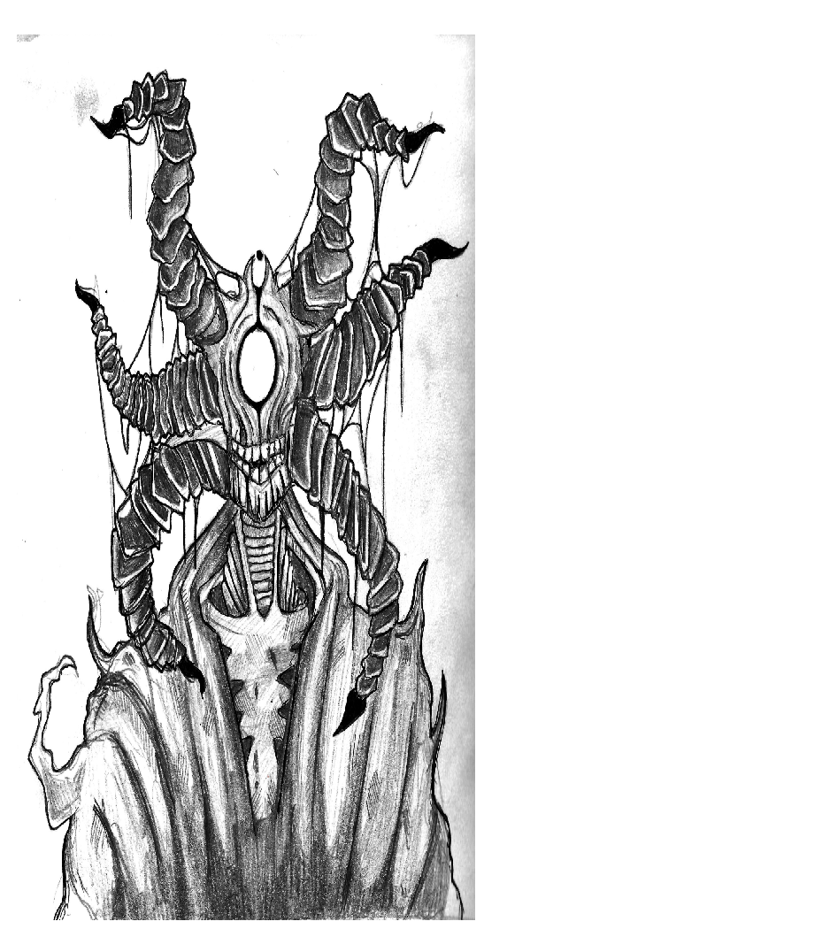

Warmth
By Ebony Hogan
I wonder why alcohol feels warm.
The first sip burns down my throat and heats my stomach-
Even the low percentage stuff I drink in the garden
on summer days makes me burn blissfully;
despite me already cooking from the sun.
Tonight- I’m glowing instantly.
That’s what happens when you start with a shot.
It’s not a pleasant feeling but my new flatmate
insisted if you’re not drinking a fireball
you’re not drinking.
I replace the shot glass
with a chilled bottle of blue WKD
and start sipping.
The pack of cards somebody pulls out is pristine,
with our uni logo on the box.
The cards are spread around a cup and
the game begins.
I’ve been to my fair share of house parties
so I know to drink on 3, 4,
and drown in the waterfall.
By the time we get to the bus stop I’m happily, hotly drunk.
I can still walk straight but every joke
seems ten times funnier than usual
and I’m not shy about giggling with the girls
speculating which of us won’t be going home alone.
Someone pulls his phone out and plays music loudly.
When I’m sober I hate people playing music in public spaces
but now me and the girls
screech a song different to the rubbish dubstep playing.
We opt for a 90’s pop song instead.
Eventually he caves and puts the song we’re singing on-

a remixed version obviously.
The bus stops and we dance into the street.
Then, we dance down the queue to the club.
A bottle gets pulled out of a pocket
and passed around.
It tastes like pure vodka
but we all sip it anyway,
sharing saliva around the bottle top.
The liquid pours and the heat burns my throat.
Each of us gets a stamp to the back of the hand and suddenly we’re inside.
We find the
perfect spot
and then.
I dance,
arms above my head
and then
running down my waist.
There’s just enough room for me to spin
and I do,
short skirt still clinging to my thighs.
I spin.
I drink.
I dance.
I’ll do it again next week.

The Soulflare Tome-Ar
By Caitlyn Simpson
Pausing in front of the antique door, my eyes scanned over the carved grooves on its surface before settling onto the doorknob. It had been made out of brass by my great-great-grandfather, and the lion’s head that formed the handle had always frightened me as a child, although I think that was what he wanted in the end. It’s mouth was open in a permanent roar and its lifeless blank eyes kept constant vigilance on the hallway surrounding the door, and I always imagined it jumping out and eating me whenever I passed it. Now, as I stand here, I find myself hesitating in the face of the old, varnished wood. However, my curiosity got the better of me and, with a shaking hand, I turn the ornate doorknob and push open the door to my father’s old study. The hinges creak, stiffened by the long years of disuse.
No one had entered the study since my father had died; he had forbidden anyone to enter long before then-not even the maids were permitted entry to clean the place. After his funeral had taken place, the room had been locked without anyone ever having entered, something my mother had insisted upon, even going so far as to oversee it herself. Not even she had ever been in, and it always confused me as to how she could never have gotten curious enough to investigate. She had lived in the house for another twenty years after his death, and had never been inside. While I might have found this odd, what always confused me more was the blanket of silence that fell over the house. The subject of my father and his life as a discussion point became almost taboo to those who resided in the house, and if anyone from outside ever brought it up, the subject would be quickly changed. It was one of the many unspoken rules that existed within the walls of the old Manor House: you never spoke about the study, or the man who used to reside there.
I was stopped in my tracks by the wave of cigar smoke and single-malt whiskey that hit me as the smells rushed to escape. As the door swung open, the smell brought back a wave of memories I thought I’d long forgotten: my father tucking me into bed at night, his husky voice reading me stories; the tablets he used to combat the constant headaches he had towards the end of his life. A lump began to form in my throat as the scenes resurfaced. A deep sorrow settled in my heart as I realised that, while I could no longer remember his face, the combination of those smells had cemented themselves in my subconscious. They were associated with him and him alone.

Swallowing the lump before it could grow anymore, I summoned all of my courage and stepped over the threshold, and I felt as though I had entered another world. The silence in the room was oppressive and sat heavy on my ears, as if I had just stepped off of an aeroplane and my ears needed to pop from the change in altitude. With every step I took, a plume of dust rose from the carpet and tickled my throat as it made the already stale air thick and dry. I ignored the urge to cough, my mind forgetting all about it as I gazed around the room, taking in all of the new sights that until now had been nothing but stolen glances through a closing doorway. The far wall of the study had been taken over by a large bookshelf which, despite its size, did not seem big enough to fit all of my father’s books on it. I could see where he had begun by ordering them neatly, but as time had passed the order had turned to chaos as his work had become more feverish in nature. Books had been thrust onto the shelves at jaunty angles wherever they would fit, causing the shelves to look cluttered and messy-two things my father never was. The paintings of old members of the family that had been hung carefully on the walls around the study had faded over time and were covered in the same thick layer of dust that had also settled on the carpet, making it impossible to see who they had depicted.
As I look around, my eyes became drawn to the sturdy oak desk that sat in front of the only large window. It had remained untouched-still piled high with papers and pens which had long since run dry, layered over books open at random pages as they were being studied. Amongst the chaos sat a crystal whiskey glass. Its insides had been stained brown with the whiskey that had encrusted itself to the inside of the glass. I guessed that that was what he had been drinking the night he died and, like everything else, it had been abandoned along with his memory.
In the centre of the desk, sitting on a cushion that resembled those used in archive rooms to protect old spines from being damaged sat a large tome. The leather on the front had been dyed red, and there were gold markings etched into it, forming a symbol I couldn’t see due to the cushion. I walked over, allowing my fingers to run across the old, worn paper as I took my place behind the peeling office chair. I couldn’t help but smile as I saw my father’s curly handwriting scrawled across the pages, forever preserved in the dark ink he had used to record his thoughts and theories on the subjects discussed inside the book.
As I stood there, I realised that, despite having been left in front of a perpetually opened window for twenty years with no cover, the pages had not discoloured and the writing was still legible, and my eyes began to wander over its contents. Confusion crept through my mind as I tried to

take in the strange symbols that sat on the page like writing. I did not know what they said or what they meant, only that they meant something, especially to my father. He had written all over the pages, highlighting passages and crossing out theories as he deemed them to be false. It was almost manic, and my heart began to beat faster as I scanned down the page, watching his usual neat curls turn scruffier as his mind slowly unravelled.
A sense of dread settled in my stomach and a shiver ran down my spine as I observed my father’s descent into madness, forever preserved in the old tome. Without realising, my hand, as if possessed by the ghost of my father through his wedding ring which I wore on my thumb, reached out and gripped the dusty page, my distracted brain faintly registering the crinkle of paper as I flipped the page over to continue following his trail.
My breath caught in my throat and I felt my heart skip a beat as I tried to interpret the image in front of me. The creature depicted in the frantic scribbles carved onto the page seemed to be on a scale that my mind could not comprehend. Thousands of eyes stared out at me, and the hairs on the back of my neck stood on end as if I were being watched, although I knew I was the only living soul in the house. I tried to look away, but my eyes were transfixed, flitting between its many piercing eyes, my mind desperately trying to understand the monstrosity depicted before me, contained within the charcoal scratches that my fingers traced as if that would give me a clearer idea of its origin.
Suddenly, a searing pain shot from my fingertips to the back of my eyes, causing my vision to go white. I managed to pull away from the tome, and collapsed against the windowsill behind me, the charcoal stains causing a slight burning sensation on my fingertips. The pain behind my eyes intensified, and I clutched my head in a vain attempt to get it to subside, although I could already feel the pain forming a migraine where it sat. My heart pounded in my chest as I could still see its eyes staring at me from the darkness, even with my eyes closed, and my stomach began to churn as I felt them burrowing deeper into my consciousness. I ran from the room as quickly as my feet would allow me, crashing into objects as I felt my way out of the study. I slammed the door behind me and fiddled with the key to lock it, hoping to seal whatever I had found inside the office forever.

Untitled
By Krisztina Tancsa
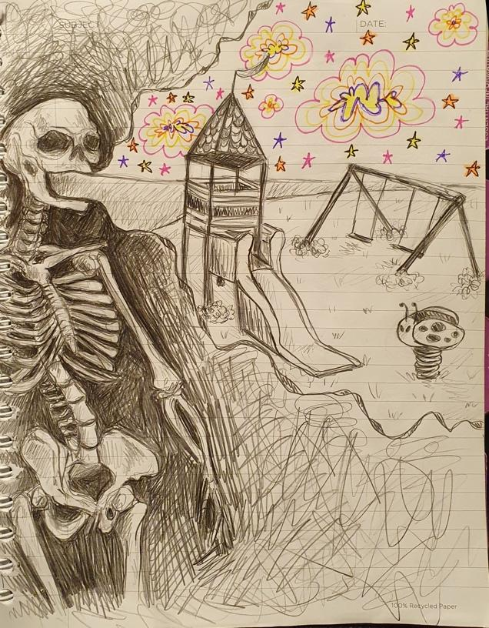

For Arthur
By Cydney Warrington
His chair sits in the corner of the room, facing the television. A window lies above the chair; allowing the beaming sun into the cosy space. The furniture stands in the same place as when the young couple originally moved into the house. The smell of bergamot attempts to cover the scents that rooms like this encounter; a room where lives have been lived. Age has seeped its way into the chair, the woven material worn in the middle from where he spent hours sitting. The wooden armrests faded and marked by countless cups of tea resting on them. From day one, the chair had always been his place through the chaos of the house where there was peace. However, there has been little peace in the past couple of years.
“Whatcha doing sitting in silence?” Lily asks from the doorway. Arthur lifts his head, watching as his daughter walks in and turns on the old radio. A song he doesn’t recognise starts to infuse itself into the air. She turns it down, smiling over at him, before she rests a mug on his side table and moves to sit on the other chair with her own mug in hand: “How are you feeling?” she queries taking a tentative sip.
“Good, good. When did you get here?” he replies, unsure if he remembers hearing the front door being opened. Taking the mug from the table he places it on the chair’s armrest, waiting for the liquid to stop steaming.
“Only a couple of minutes ago… I did shout,” she says softly, blowing on her cup of tea. “I went to the shops and got you a few bits and bobs,” he nods, watching his garden and the lone robin pecking at the ground. The silence hangs there for a while, he doesn't know for how long exactly. The music on the radio keeps playing and he continues to watch the robin. When the bird finally flies away, he feels a sense of loss. Only when he is sure that the bird will not return does he turn to his daughter.
“How are you? How’s the baby?” Lily gives him a small smile and doesn't answer for a while. He brings his cup to his mouth and when he takes a sip finds that it is cold, disappointed he puts it back on the side table. She is still looking at him and he cannot understand her expression.

“I’m ok, everything is good,” she answers, moving to grab the full cup from beside him as she takes both of them to the kitchen. He hears the kettle boil and readjusts himself in his chair. Wiping his wrinkled hands on his trouser legs, he tries to massage the achy muscles. It proves useless in providing release from the constant discomfort and he lets out a frustrated sigh.
Bracing himself up on the chair’s arms, he walks over to the fireplace and looks at the photos on top of it. The biggest frame sits in the very middle, within it holds a photo of his family; Arthur stands over his wife who sits holding baby Lily. As he looks at the image of his past, he has to take off his glasses to wipe the tears that start to fall. He doesn’t know how to feel looking at the photo so he chooses to move on and look at the others on the shelf. Photos crowd his vision as he looks at them one by one, letting the memories flood in. They play out in his mind, all of the little moments captured with a click. He stops at one of the black-and-white photos.
“Whatcha looking at?” Lily asks from behind him, a new brew in hand. At first, he doesn't turn towards her, instead just looks at the photo like it’s the last life vest on a sinking ship.
“This was taken the year we met,” Arthur says quietly. He knows she understands what he is talking about. “She was so beautiful, I had never seen anyone so comfortable in their skin. She just glowed.” He makes his way back to his chair, slowly lowering himself onto it. She brings the cup to the table and sits down in the chair again. They both let the silence hang there, filling the room to the brim. He had always been more comfortable in the quiet, letting everyone else do the talking, while he just listened. Now though, since there was no one to bridge the gap, he felt he had to speak.
“Your mother was the best thing that ever happened to me, you know.” He looks over at his daughter, who resembles her considerably. “That photo was taken when we went for a day trip to the Lakes.” Lily gets up and walks over to it, looking at it closely. “We met in the spring, at the university library. I was in my second year studying Maths and she was in her first studying Art History. We both reached for the same book, I can’t remember what the name of it was but it was instant; I knew I had to know her.” Lily sits back down, cradling the photo in her arms. “When I asked her out a couple weeks later, I was ecstatic, I never thought she would say yes.” He takes a breath, sips his coffee and holds the cup. “We raced to the top of a hill, she set up her camera and we stood facing each other as the shutter went off.” He takes another breath and forces himself not to look over at the photo. Vision already blurry, he takes another gulp of coffee.

Lily gets up and puts the frame back on the shelf, making sure that it faces his chair. He looks up at it and his daughter, who is not meeting his eye. She stands there for a moment and a couple of times, he thinks she’s about to say something but she doesn’t. What was there to say? Was there anything to say? As the tears start to fall he grabs his handkerchief from his trouser pocket and dabs his eyes. Lily snaps out of her haze and moves to kneel at the side of the chair. Gently holding his hand, she kisses the top of it and waits for his sobs to suspend their heartbreaking sound. Once they fade, she hugs him in his chair. He wishes that she hadn’t been there to witness his crying and pulls away first. She seems to understand and grabs his discarded mug and goes into the kitchen to allow him a moment alone.
“I want to go visit her, Lily,” he says abruptly when she walks back into the room. She starts to shake her head and he lets out an exasperated humph. “Before you go on about how I can’t because of this and that, I am. End of story.” She shakes her head and he watches as she turns off the radio still playing unfamiliar songs.
“I’m sorry, I really am, but you can't. It's just too much for you to do,” she says in a rush and sits back down in the chair. He keeps trying to catch her eye but she grabs the tv remote and flicks through the channels. Knowing it’s useless to argue, he watches as she picks a black-and-white movie that he has seen before and they lull back into silence. This time, however, it’s a suffocating silence.
---
Arthur sits in his chair and Daisy takes deep breaths, grateful that the conversation didn’t turn nasty as it normally does. It’s the same thing every day; with different variations here and there but overall, it ends with him wanting to go see Grandma. More times than not, his paranoia seeps in and he yells that she wants to trap him in the house or that she wants him to die. When that happens it always ends in her crying and him being silently angry for the rest of her visit. He never remembers it the next day.

Luckily, he’s quiet now and she can let her mind wander far away. She doesn’t like coming as much as she used to before but before was when her Mum used to be there as a buffer. Lily always knew what to say to Grandad. When it started Daisy didn’t mind that he thought she was her Mum; it's a compliment and she took it that way. Now though, it’s too

painful to correct him but also too painful to hear it. Every time she visits, she tries to say as little as possible and doesn’t call him Grandad because it confuses him. She has tried different ways to correct him or remind him that she’s his granddaughter but it's just too much for him.
Even though visiting him hurts, she makes sure that she is with him every day at the same time. She knows it is what both her Grandma and Mum would have wanted, for them to keep each other company. With her attention still on the telly, Daisy doesn’t realise Arthur has fallen asleep until he starts to snore. Looking over at her Grandad, she tries to remember how things used to be so that these bad moments do not poison the good memories of the person that he used to be. Putting a throw over him, she kisses his forehead, says goodbye and makes sure that everything is turned off.
When she gets on her bike she considers going straight home, it's been a long day and she knows her body is exhausted. But when her feet start turning on the pedals she heads in the opposite direction of home; she heads in the same direction she always heads when she leaves Grandad’s house. The brisk autumn breeze stings the tops of her ears and nose, soon she will have to start getting the bus because of the cold. She prefers this though, being able to ride her bike and be in control of where she goes. When she turns into the Crematorium, the temperature drops. As usual, it doesn't take long to get to the grave. She reads the stone as she has thousands of times before:
‘In Loving Memory Of
Iris Myrtle
Age 66
And
Lily Myrtle
Age 39’
It never gets any easier, having to read their names next to each other. Sinking down to the floor, she sits in front of the grave. The tears fall freely and she doesn’t have the energy to wipe them away.
“He still didn’t remember me, Mum. He kept calling me Lily and I didn’t correct him. He wanted to come and see you but I don’t want him to come and see both of your names and then have to live through it again.” She takes a shaky breath. “I sometimes think that it's better that he doesn’t remember that you're gone, Mum. I can’t imagine him having to realise that not only did he lose Grandma but he lost his daughter too. I wish I was lucky enough to forget you are gone.” She digs her fingers into the

dirt, letting it seep under her fingernails. Trying to breathe slowly, Daisy closes her eyes, paying attention to the wind blowing the fallen leaves across the ground and the birds chirping in the trees. “I can’t do this alone,” she chokes out.
When she leaves an hour later, she cycles to her flat. It's dark and cold when she goes in, but she can’t be bothered to turn the lights or heating on. Instead, she walks to her bedroom and crawls under the covers. Her crying continues, soaking the pillow under her head with her tears. Tossing and turning, she begs her mind to rest. Still, she cannot stop her grief from swallowing her peaceful thoughts. Only when her body is truly and utterly exhausted does she sleep.

Knight
By Salis Fern

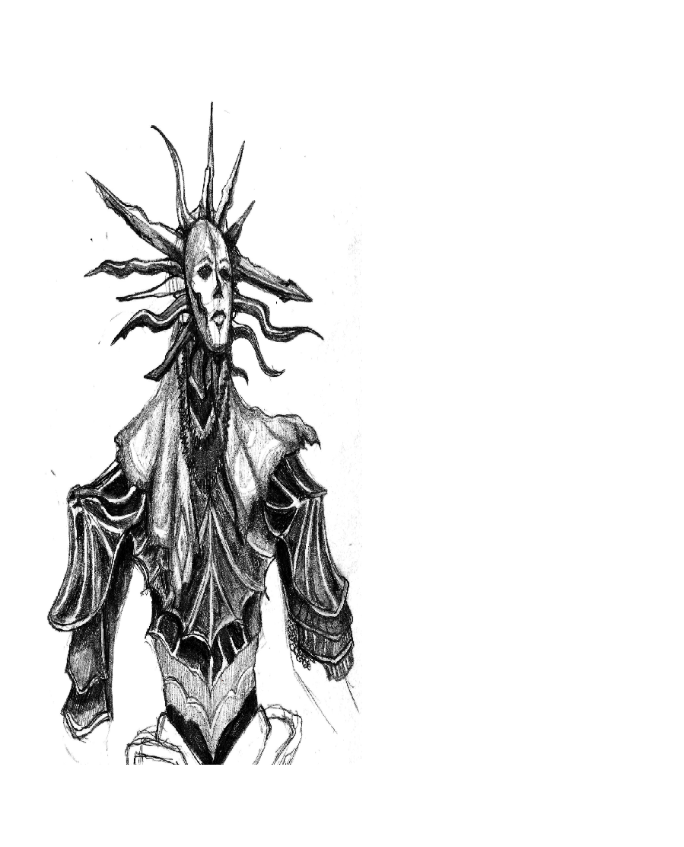

Love after Loss
By Kristin Challender
Ever since I first met you,
I’ve felt wonderstruck by you,
Every fibre of your being is beautiful,
Bringing joy into my life after loss,
When I pull your body close to mine,
As fragile and delicate as a flower,
Your scent of jasmine and orange blossom,
Provides me with a sense of comfort,
When grief had left me dead inside,
Since being in your healing presence,
You’ve sparked the life back into me,
Like a bright moon, surrounded by darkness,
Although I cannot forget my past,
You’ve renewed in me a sense of hope,
And freed me from my mental distress,
Enlivening my mind and spirit,
Despite the shadow of devastation,
Being cast upon us both,
You bring the light, and the electricity,
Between us grows and grows,
Having both suffered from loss,
Losing everything we once had,
You have re-awakened my damaged soul,
You are my refuge, my salvation,
Marley.

A Changed Constant
By Jomkhwun Thongprasong
Even when overcast by the shadows of its ruler’s negligence, a wilting nation still has a constant. Whether large or small, abstract or tangible, one exists and breathes. For this rundown land, this constant huddles away in the corner of a crumbling mountainside.
Tirelessly beating is the heart of the failing blacksmith faction: Tsubaki’s Forge. It’s one of the few smitheries still open despite the long-depleted morale and pockets of the people who used to frequent for weapon repairs and commissions.
At its height, back when the nation was dressed to the nines and drunk on international trade, the smithy’s head blacksmith could stand by the side of a village chief and outshine him. But that was the past. At least thirty years ago, if the current successor remembers correctly, not that he cares enough about the history of Tsubaki – or any of his predecessors – though. After all, what mattered to him was who would come to the door next and whether they’d pay him with rice bags or rags. He had a ‘surviving’ to make – ‘living’ was for the rich and privileged.
Tonight, the seemingly ceaseless beating of his hammer is accompanied by the equally ceaseless rain outside. It had been raining for weeks now, and the only thing that had marked the passing days had been villagers from the village about three miles from the forge running to him for bolts and tools, preparing for a possible flood. But even they had stopped coming, and his rice bags were slowly, but surely, running out. But what can he do?
He had accepted he was going to die anyway.
Amidst his sombre musing and the breath of silence between each beat of the hammer, he hears splashes near. The rhythmic patter of leisurely but purposeful footsteps on the pebbles and sodden earth pique his stomach’s interest. Perhaps he’d get lucky and get 2 kilos of rice if this is someone from the village. At least, that’s what he had hoped for. But it wasn’t meant to be.

When he raises his head, it’s a stranger that he finds. Under any other circumstance, he would have frowned, but here, his muscles falter. And the hammer misses its beat.
“Can I help you?” the blacksmith manages as he sets down his hammer, noticing how dry his mouth has gone as his eyes follow the newcomer as they glide from the entrance to the opposite of his anvil.
At this distance, he can see that whichever god that had made this stranger had made no mistakes. Their feminine appearance would convince him that this stranger was a runaway shrine maiden, but at the slightest catch of a shadow, their face became that of a handsome nobleman. They even had a beauty mark on their left cheek to complete the look. Regardless of their gender, it was a face that could cause irreversible damage to the hearts of its admirers. He gulps when their eyes finally meet.
The stranger’s cobalt eyes gleam like tempered steel in the firelight from the forge as it sweeps over him and his workshop. Their eyes are accented by their pale skin and the long charcoal hair framing their face, highlighting their high cheekbones too.
When he realises, he’s been staring, he also realises they haven’t answered either. During the silence following his question, the stranger had chosen to observe the forge and the blacksmith like one does when trying to give value to art pieces instead. But their attention on the blacksmith had lasted seconds before turning away, white robes akin to funeral garbs fluttering with the movement.
The blacksmith clears his throat and opens his mouth to speak again, only to be interrupted.
“Teach me your craft.”
“What?”
“Teach me your craft.”
The blacksmith is too stunned to speak. The doll in front of him wants to become like him...? He almost guffaws.
“I refuse.”

“I’m serious.” The stranger states, expression remaining impassive.
“And my answer is still no.” The blacksmith replies again and returns to hammering the metal he had been working on.
"Why?"
"Well," the blacksmith waves his hammer up and down at them, “look at yourself. You’re like a doll. I could-” The unwavering, impassive stare from the person in front of him makes him interrupt himself, catching his thoughts and tongue before he wades into dangerous waters. It’s almost as if they had pinned him up against the wall, knife at his throat, whilst waiting wordlessly for him to continue. He shifts uncomfortably and looks down at his hammer, returning to focusing on his forging as the newcomer pulls up the stool by his workbench and sits where they had previously stood, leaning back and crossing their legs. The blacksmith looks up again, audibly swallowing when their eyes meet, resuming the prolonged eye contact once more.
“Go on.”
There’s a pause before the blacksmith slowly mutters, “No… I sense I’ve made a mistake of some kind.” The blacksmith eyes the smirking stranger when they lean forward, their eyes giving off the impression of a satisfied snake with its coils wrapped around its prey.
“Hmm, good. You have half a brain so take me as your apprentice.”
“No!” The blacksmith shouts, eyes wide like a doe captured in the headlights of surefire death, hammer once again missing a beat but this time clattering to the ground. “No, no, no, no, no. I refuse.” His head shakes as he waves his arms frantically, eyes bulging and darting about for a scapegoat from his hammer to the anvil then the rice bags by the door. Eyes running between the stranger and the rice bags he stammers out, “I- I wouldn’t be able to feed you…”
“I can feed myself,” the stranger replies softly, eyes full of mirth as they watch the panicking man. “I just need shelter an-”
“I don’t have room for two; the house is cramped and there’s only one bed,” the blacksmith rushes, growing ever redder under their amused stare.

“Then I’ll share your bed.”
“W-what?” With that comment, they might as well have poured water onto a raging fire. The stranger can practically see the steam evaporating off the blacksmith as the man stumbles backwards from that hit, red in the face with his mouth hanging open.
“I’ll share your bed,” they reply with a smile, pleasure never faltering on their visage.
The blacksmith’s mouth shuts, lips and limbs trembling as he covers his mouth with a large gloved hand.
“Fine! Have it your way.” He shouts, taking up his hammer again, fighting his resistance as he crumbles under their smile. There was no other option, except to take them on as an apprentice.
----------------------------
The rain has finally stopped, giving way to pallid skies and glaring rays of late autumn sun. Five months have passed since, and the two strangers turned roommates and coworkers are now on the cusp of winter and their sixth month together.
From their time together, the blacksmith has learnt the androgynous snake’s name: Yuushin (友心). It was ironic since the characters of their name meant ‘friend’ (友) and ‘heart’ (心). The last few months living with them had been verging on a punishment from Tartarus.
Not because Yuushin had been some sort of raving demon causing chaos and making his business erupt into flames but rather because they had brought a new constant to his life… a change.
From his workshop to his house, little relics and remnants of Yuushin started to collect like dust – at first unnoticeable, until there was a noticeable layer collected in corners that used to be empty.
Even his bed had been tainted.
Before he'd have enough room to stretch out and sleep at whatever hour without concerns. Now he finds himself sliding into bed the way you’d slip into glass slippers; conscious of how loud he was or how much space

he was taking up as he joined the smaller body. Now he finds himself seeking the warmth of another when it drifts away or slips out from under the covers. Now he finds himself unable to sleep unaccompanied in his own bed. It was uncomfortable.
Since when had he become so attached?
“You don’t get out much, do you?” Yuushin asks simply as they watch the blacksmith work as they work on carving a pattern onto the hilt of a sword.
The blacksmith looks up briefly from whatever he’s smelting, pausing briefly to think before nodding and replying, “I suppose not.” He returns to his task as he listens to what Yuushin has to say in reply.
“You have no friends either, huh?”
The comment makes the blacksmith’s movements stutter. “You… didn't have to say that out loud.” He sighs as he looks up over to Yuushin again.
The smaller of the two snickers and carries on with their task. “Not my problem, it's true.”
“No, it's not.”
“And your proof being?”
“You.” The blacksmith states, staring into Yuushin'n's eyes as he continues to profess, “With you by my side I-”
“Finish that and we'll become a sappy, madly in love, married couple.” Yuushin deadpans, less than impressed with the blacksmith's display of heart. A particularly harsh stroke of the knife nearly decapitates their thumb from their hand as they resume their work, teeth gritted.
“Why don't you like it when I'm vulnerable around you?” The blacksmith asks after a long moment of silence. But he gets no answer. Nor does he push for one.
“I’m sorry.”

“Hmm, good. You have half a brain in there still.”
It becomes an unspoken rule: never verbally express your feelings for the other. Actions were fine but words were alien and unwelcome. Feelings were meant to be seen, not heard. If they were acknowledged, the two would have to acknowledge their attachment to one another too.
And that was another uncomfortable thing.
Attachment was a dangerous thing in these days of absurdity. Who knew if the stranger you had taken in and grown fond of was actually some rebel lying in waiting for the right time to pounce and soil the ground with your guts… The blacksmith shuddered to think of meeting such a fate. But so far he had had no reason to believe it would happen.
And yet he did not have the nerve to express such feelings – even if his feelings were meant to show his trust and belief in the other.
----------------------------
Three months passed and gave way to gaping shadows and excessive snowstorms. With the snow came nights when the blacksmith had to relearn how to sleep by himself. Those nights were the longest and Yuushin’s absences only grew more frequent with the worsening of the weather. He couldn’t say much either as he too had suddenly been swamped with work. If it weren’t Yuushin being gone for work then it would be him. Sometimes he believes they’d have more time together if it weren’t for how proficient Yuushin had become.
“You should be careful when you go out these days, there's a beast on the loose.” The blacksmith says to Yuushin, puffs of steam billowing from his mouth and crowning his face like smoke does to a forest when a forest fire rages. “It’s murdered five soldiers and two villagers so far,” he mutters as he brushes the fresh snow still clung to his jacket from his return from a delivery to the village.
Whilst the blacksmith had left, Yuushin had remained to take care of the forge, waiting for his return or a customer to come. Now that he was back, their eyes bore into him, watching with morbid curiosity at the mention of the new development, asking, “Are you scared of the beast?”

“Like any sane person, of course, I am,” the blacksmith had grumbled out before he had ushered the other further into their home. But he had felt far from the definition of fear when he came face to face with the ‘beast’ nights later after going to search for Yuushin amidst a snowstorm, fearing that the smaller had gotten trapped in a cave or worse.
“Yuushin?”At the sound of the blacksmith’s call, it turns its head.
In the clearing of snow muddied with crimson and bodies and a ring of scrutinising trees, the creature stands. At first glance, it could have been some spirit beast with its four luscious, cream-coloured fox tails embracing its delicate body, pointed ears crowning its head, curved claws and golden eyes piercing the night. But with closer inspection, the blacksmith can see the brand of the rebels’ slaves on its neck, the way moonlight reflected its skin the way metal does, the cracks of metal sheets pieced together… the porcelain-coloured metal that he had moulded and helped the monarch create a sacrificial vessel to a god, wishing for said god to give her a loyal dog or a weapon. And now those body parts, the prosthetics he had been commissioned to make made a whole being. A being that he had embraced, a being that had killed, a being that stands in front of him, asking:
“Do you fear me now that you have truly seen me?”
“No. And I don’t care if you think that by me saying this will make me sound like your accomplice, friend or lover but… with you by my side, there is nothing that I could fear – not even death at your hands. I would be blessed to die at your hands.” The blacksmith declares, standing proud and defiant, his sword lowering to his side before being discarded.
“Well, you’re a fool.”
“But I’m your fool.”
Yuushin shakes their head, smiling solemnly as their body reverts to the human he has gotten to know. The two draw closer and reach out to hold each other when they’re close enough.
“I won’t tell anyone. I’ll turn a blind eye to this so you do what you need to do.” The blacksmith whispers to Yuushin, pressing his face into the other’s cheek. Yuushin leans into him as they listen to him continue, “I would die for you. Worship you back to the heavens and follow you to hell.” His grip tightens on Yuushin as he speaks, lips ghosting the skin of

their cheek before they pull away, only to nuzzle back into the crook of his neck.
“Silly man. I am neither a god nor a machine. I am an abomination and a weapon.” Yuushin murmurs with a smile, taking his hand and kissing his palm before continuing in hushed tones, “To die at my hands would be no more an honour than to betray your nation for crumbs.”
“But-”
“No buts. They captured a god with a vessel and made me a slave. You? You are nothing more than a blacksmith, a little boat caught in treacherous waves, caught in the grander scheme. You were never meant to get involved… it was just misfortune.” Yuushin says softly as they draw away to look at the blacksmith who looks to the ground at a loss, not expecting such a reply.
“But I ma-”
“Listen to me.” Yuushin commands, cupping the blacksmith’s face, forcing him to take in their features – to sink into the loving abyss of his eyes as he had for the last few months. “If you value me, you will forget about me. You will continue to live for me and yourself. You will do as I say and you will kill me.”
“No,” the blacksmith croaks out, hand trembling as he reaches up to grasp at Yuushin’s. “I- I can’t do that. Anything but that. Don’t make me do it.”
Yuushin simply shakes their head, smiling as they pull him closer, and then kissing his forehead. Their voice comes out firmly, “Promise me, Kisho. Promise me you’ll live. It’s you or me and between the two of us, I want you to live. I choose you over myself. Do not argue with me.” They take his hand and press a dagger into it – a dagger with the royal emblem, it might as well have been a royal decree.
“I promise.”
Yuushin gives him a smile; leaning in and nuzzling their face against his. The blacksmith – no, Kisho, had let himself break now. The tears rolled freely as he clung to Yuushin, refusing to plunge the blade into the only person who had recognised him as more than just the blacksmith. He presses himself closer to his companion, readying to do the deed.

And by some sick miracle or curse, Yuushin doesn’t feel his hands slip the blade into the gaps leading to their heart.
No, Yuushin doesn’t feel anything but the trembling body of Kisho tensing and then sagging into their arms. A wet cough and the feeling of droplets thicker than water splattering onto the crook of his neck where Kisho had buried his face. It’s only seconds but he watches Kisho slip from his arms, body crumpling unceremoniously onto the snow with a smile and the dagger protruding out his chest, rasping out, “Live. Be free. Don’t let them catch you.”
“You fucking imbecile!” Yuushin cries as they collapse to the floor, hugging Kisho’s body. “How could you? You stupid, stupid, stupid man,” they mutter as they rock the body back and forth as a mother does when she soothes her child, desperately pressing kisses to Kisho’s pallid face as if it would tell him all their secrets, all their feelings and thoughts – as if it would bring him back.
Kisho had betrayed them. The nation, the people, Yuushin, he had betrayed them all for Yuushin to ‘live’.
But Yuushin did not ‘live’ on. They stopped ‘living’ when Kisho breathed his last, choosing to despair as he buried the body and went back to the forge. They shed their skin and melted into the embrace of the only thing left of Kisho, they returned to the continuous din that belonged to the life of their blacksmith.
Yuushin wouldn’t live on but the blacksmith would.

Piece Two from Flowers & Decay
By Charlotte Goddard
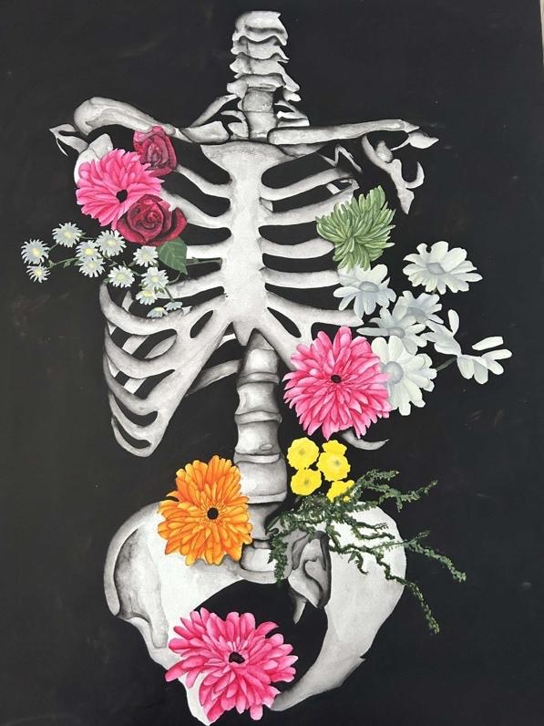

Trainwreck
By Lucy Radcliffe
It was a fight to get on board. The doors were beeping like crazy, giving the warning call just as they jumped on. Hand-in-hand with her friend, laughing and jeering along the way. They squeezed into a booth beside another pair of friends who chatted amongst themselves. She pulled her plug from her bag and jammed it into the socket, sticking her cracked phone on charge. It had died twenty minutes into the concert, ruining her chance of recording snippets of the performance to show off to her classmates on Monday morning. She would just have to recall the spectacular events and recite them to them.
“My ears are still buzzing,” Laughed Kamron, rubbing their ears with their hands. She grinned and nodded in agreement, she could feel the ringing in her ears too. Thumping hard through her veins, racing as fast as her heart did when the band came on stage.
“What photos did you get?” She asked and Kamron pulled out their own phone, it was clean still having the screen protector on without any under the surface bubbles. They scrolled through the videos of bright lights, glitter and screaming fans. She smiled at the selfies of the pair and they giggled at the silly photos of them mid-jump or mid-lyric, mouths wide with pride as they shouted the words back to the stage.
“I think I’ll put this one on Instagram,” Kamron said. They had stopped on a photo of their cheeks mashed together - squishing up till they both looked like hamsters hoarding snacks. Cheesy smiles, squinting eyes adorned in blue and black eyeliner.
“Noo, you can’t!” She exclaimed, trying to pull the phone from Kamron. “Look at me, I’ve got lipstick on my teeth!” Kamron had pulled their phone back just in time, cackling as they did.
“You look adorable, who cares?”
“I care!” She leaned on their shoulder, her eyes darting to her phone briefly. It was still black, no sign of life in sight.
“You shouldn’t care, you’re too pretty to care.” Kamron said to her. Her face flushed a little at the compliment, glancing up at them for a moment

then looking back at her phone. She wanted to see what she had captured before her phone had rudely decided to give up on the whole event.
“Thanks, Kam. I just don’t want your friends to think I’m a mess.” She responded, tapping on the cold screen to see if it would react or turn on.
Kamron snorted, locking their phone and resting it on their lap. “You are a mess, but in a good way.” They looked out the window as the dark countryside they now whizzed by. Rolling fields of navy and grey with the occasional one having cows or sheep still roaming around. “But seriously, you’re fine, nobody is going to judge you and if they do, so what? That's their own insecurities, not yours.” Her lips twisted into a thin, weary line. As if she had a knot tightening in the back of her throat. She watched the aisle. Colourful people walked up and down the walkway - adored in sequence, feathers and fluff. Each bright and beautiful. Faces covered in pinks and blues and purples and greens, as if unicorns had vomited on them all. The chatter was deafening, howling laughter and singing the same songs they had all been screaming an hour beforehand. She was surprised nobody else had seemed to have a sore throat or developed a croak. She pulled herself away from Kamron, remaining quiet. “Did I say something wrong?” They asked, looking down at her with a slight frown.
She shook her head quickly. “No, no, it's fine, I just don’t know how to respond. That's all.” She looked down at her hands, at her chipped polish and chewed up nails.
“Listen, I won’t post it if you don’t want me to,” Kamron said, leaning into her to speak so she could hear them over the loudness of the train.
“No, it’s fine,” She quickly responded, looking up at Kamron with a small and shy smile, “I’m just being stupid, you’re right, I shouldn’t care.” She said with a slow nod, turning her head to look out the window as well. Kamron looked at her and they wanted to apologise. They wanted to rewind and start the conversation over again; they felt that they had made things awkward. Perhaps they had been too forward. Kamron watched her, she deeply sighed and continued to stare out the window. The longer they sat in silence the worse they began to feel about the whole thing. They slumped back in their seat, regretting all their life choices up until this point. They decided to close their eyes, focus on their breathing and try not to overthink too much. It felt like an hour had passed by that point, the train had stopped and a good bunch of people got off the train - including the people they had been sharing the booth with.

“Eve, I’m sorry.” Kamron finally said, assuming now was a better time to talk with the privacy. Eve was positioned away from Kamron, fully facing the window at this point. “Eve? Did you hear me?” They asked, reaching a hand up to tap her shoulder - maybe she was sleeping?
When she turned to face them, her face was red and splotchy. Was it something they had done or said? The light of Eve’s cracked phone reflected off the window. All the missed calls and texts from the two hours concert were still coming through. They didn’t know what to say or do. “I didn’t mean to,” is all they could muster up.

The Meet Cute
By Cydney Warrington
She checks her phone,
led by her feet. Ahead,
she hears church bells.
As a storm brews,
the rising tide rebels.
He checks his phone,
waiting for her.
His battery almost dead.
A bead of sweat blurs
on his furrowed head.
She takes short breaths,
the spot decided,
now a distant speck.
Her fingers intertwine,
waiting for what’s next.
He takes deep breaths,
paces one, two, three.
The tree before him sways
left, right, left, right.
His vision in a haze.
She reaches the bench,
blues, reds, yellows
twirl with the grass.
The space lies empty,
she lets a sigh pass.

He watches the bench,
shaded by wide branches.

Unaware of her arrival,
he lowers his gaze as
the fallen leaves spiral.
They notice each other
in the same moment.
Features faintly familiar,
the uncertain mist thins.
Tentatively, they observe.
He stands frozen,
she gifts him a smile.
Exhales mingling in the crisp air,
their synched heartbeats
muffle the birdsong.

Factory
By Ebony Hogan
When I look around I know that this is not where I will be in ten years. Not that being here for ten years would be a bad thing. I hold a massive amount of respect for people who spend their lives in manual labour jobs. Without them, our society would collapse. It’s the dictation I can’t accept.
Come in at six, let us scan your face or your fingerprint or your assigned ID number like you’re a robot. Stand in one spot for eight hours and meet our quota or we’ll fire you. Let other adults yell at you and don’t yell back or we’ll fire you. Don’t go to the toilet – we’ll fire you. Oh, we know it’s illegal to fire you for no reason. But there’s nothing you can do about it.
You get one break for half an hour. We won’t pay you for that, but it’s not optional. We won’t pay you extra if you go above your quota. Breathe in the fumes that will kill you. It’s not optional.
If anything goes wrong, we’ll blame all of you.
If you can deal with the dictation; the stifling, choking rules, there’s also the racism to endure.
It’s a contradictory environment. It’s easy work, with no experience needed, which means it attracts a lot of migrants, as well as people who are too stupid to know migrants aren’t their enemies. There is a sign in the bathroom reminding you not to rub shit on the walls, which is repeated in at least three other languages I can’t read.
Half of the workers come from a different country and it seems the other half hate people who do. These are the people who complain about ‘foreigners stealing our jobs’. And here they are, working alongside each other. More than once, I see English workers ask a large, dark-skinned man how long he’s been here.
Every time, he smiles a patient smile and replies in a thick cockney accent that he’s only lived in the midlands for two years.
Whether you are an immigrant or you hate them, you’ll work side by side. It’s not optional.

-----------------------------------------------------------
As soon as I step inside the building for the first time, I’m in awe of how big it is. In theory, I know that warehouses are big. Everyone knows that. But it’s a different beast altogether to feel it. I can’t even see the full thing from the entrance. My view is blocked by sky-high shelving full of plastic-wrapped pallets. But I can feel it in the way I breathe. I breathe out and my lungs are a mile away.
It’s a cool kind of cold; and oddly quiet. And lovely. I could sit in here and feel relaxed for hours, watching the disconcertingly silent forklifts chug past me. I think of a poem I read last week about liminal spaces and the idea that we can be ‘between’. We don’t have to be in the moment, we can be between moments. Here, in this building as large as a city, I am between.
And then I go through the arch into the packing room and everything changes.
Two radios are playing the same music from opposite ends of the room. They’re not quite in sync and the deep hum of conversation reaches every corner. The people around me are speed-walking, as if they’re in a rush to get to work. As if their lives depend on it. I take my time, speaking to somebody to help me find my place and there I stand. I listen to the instructions. I get one slow test to settle myself in.
And then we go at full speed.
Step one, step two, step three, four. Pass the bag down the line for the next person. One, two, three, four, pass. One, two, three, four, pass. Swap supplies. Go again. Don’t stop. Your life depends on it.
We get into the rhythm, working like machines that never need oiling. The woman across from me talks about her son. Her three month old son who almost died when he was born. Now, he’s at her parent’s house while she works full time to provide for him.
The woman beside her is my age. She has two kids, both under five with another one on the way. They’re in nursery- the government pays for somebody else to look after them so she can work full time so they have a house they can all sleep in.

There’s a man across the factory. He wears a t-shirt that declares him ‘Dave the packing King’. I wonder how long he’s worked here to get a shirt like that. It seems to be accurate, he’s doing his job without looking, singing along to the radio with a mouth that has no teeth in.
My line leader is fresh out of university. She did a course in the humanities and now she’s here, getting fifty extra pence an hour to get yelled at on our behalf. The other line keeps taking all the supplies instead of sharing them evenly and it makes it look like we’re not doing our jobs.
I chat with the woman beside me (it’s a very female-led-line). She tells me she looked for ten months before she found this job. All the other work she saw was too far away for her elderly dad to drive her and she doesn’t have her own car. Most people I’ve spoken to have a commute that is over an hour long- myself included. She tells me that Dave has worked here for ten years.
I will not be here in ten years.

When Is Rotten?
By Star Jones
Cheese gets bluer with rot, so the richer the cheese becomes.
An apple is rotten with browns and greys, but an apple -still- it is.
Milk gets sour with rot, so the thicker it starts to chunk.
Compost revitalizes but it’s full of rotten things.
A loaf of bread is fluffy with rot, but it is alive and growing.
A person is rotten, so they’re locked up.
But their rotting was stopped.
How are we to know when we have rotted?

Nausicaa by the Shore
By Lauren Bartlett
“Fare well, stranger; in your land remember me
who met and saved you. It is worth your thought.”
(The Odyssey, transl. Fitzgerald)

One night a few weeks after Agnes left, I had a dream I was floating on the ocean, my head back, and body splayed out. I knew I had a body at least, but couldn’t imagine what it looked like or why I did; though I could see the sunlight through my eyelids like paper, and feel its warmth distantly, indistinctly, somewhere. There wasn’t much more I could feel, so I don’t know how I knew I had a body and wasn’t just the water and nothing more. The waves came and I drifted here, where nothing seemed above or below or around or inside me. I started to wonder why. In my mind, I started to measure how deep the ocean must be below me, and I imagined darkness. A rhythm began in me – da dum, da dum – of heart pump and blood rush. And when my eyes snapped open, all I could see was blue light and the shore.

I now doubt I would have ever shared any dreams with her if she had stayed. The muscles around her mouth wouldn’t flex, twitch, or loosen. Her eyes wouldn’t move either. I know they’d still sit firm, green and glossy, above rounded cheeks like the first time she came into the inn. She cared deeply for her outer appearance and was proficient in maintaining it – something I could never accomplish as naturally, though that goes with having emotions that are somewhat like those of a child: easy to stir and easy to change. Agnes was harder to read than I liked, and her inner life was always a mystery.
“How much for a room?” Agnes had said, looking down into her polka-dot purse as if it should have the answer.
She stood a bit away from the front desk, and from where I was most of her body was in view. She was tall, not remarkably so, but taller than me, and slim too so that she appeared like a thin line that seemed to fit perfectly into the decorative rosewood panelling behind her back. Nobody else was in the reception and heat, orange light, and cicada buzz filled the space.

“Eighty a night,” I said, “How long are you staying?”
She then looked up and I saw her face under the spools of white-gold hair I’d been addressing. This woman was seemingly a little older than I, yet I was struck by the strange softness of her features.
“I’m not sure.”
I smiled a little, taking a second, “You’re not sure?”
“I’ll pay each night,” she assured and pushed a few banknotes over the counter under lithe white fingers. I met her there. Her hands had been cold, I recall.
It later turned out she’d been travelling to see her family when war had broken out. The Italians invaded in October 1940, forcing Greece to join the Second World War. The enemy was advancing through the northern mainland and trains had been suspended. She’d ended up, by ways surely not of either fate or fortune, stranded in our little seaside town for some uncertain time.
“Stay as long as you need. You must be tired. Rest here and eat well where you’re safe.” I said.
The edges of her lips melded into her cheeks when she spoke. “What’s your name?”
“Eleni. And you are?”
She was glowing from the inside when she said, “Agnes.”
“Agnes.”
And there began the events of the next few months that had such guide over my person that I feel I no longer fully recognise the woman I now write about two years later:
Throughout the time she stayed with us, though especially during that long winter when the hellebores flowered, a strange sort of quiet confidence came over us all. Nicholas had left home to join the troops in defending the country, and the inn was empty the whole season but for the four of us.

We all could see the way Mama’s face would harden at any mention of her only son, even if nobody addressed it: her lips flat and unwavering, her cheeks taut – and her prayers that the Lord bring him home safely I often heard late at night through my bedroom wall, the slight shuffling of rosary beads like a distant ticking clock. Yet Agnes’ stay offered us all a comforting occupation. Mama and Baba put themselves to delivering all the hospitality they were capable of, and in return, Agnes gave us smiles and stories that I spent most of my time receiving with delight. Baba was particularly fond of her, and they’d discuss politics together. Mama endeared her with nearly as much affection as she did me. It was in this way we were hovering on the edge of assurance. In short time, we had a new stability to live inside for a while.
My own relationship with Agnes was less subtle, less comfortable, and built on more passion on my behalf. It was a crisp November, early morning that we next spent time alone.
“Eleni, dear, could you take this letter to the post office?” Mama had asked, lifting her head and all its heavy elegance from the writing desk in the corner.
The rest of us were sat around breakfast. In front of the table, there’s a tall window facing the sea and it’s always been my favourite view, especially when the sun is not fully risen yet like that morning and the water would gleam in flashes of orange and pink. I remember stealing quick glances of Agnes under that light from across the table.
Baba didn’t look up from his paper when I stood up, his bread still untouched. I took the envelope in my hands, sliding the smooth surface between my fingers. Looking down, I read it was addressed to my brother. Mama didn’t say it was. But Agnes offered to walk with me, said she wanted to see more of the town – so without a word of question from myself, we put on our hats and boots and stepped out of the house.
It was cold when Agnes closed the door behind us, her eyes squinting and nose scrunching against the guava sky.
“So where are we going?” She asked, turning to see my face. Her blonde curls were pinned up stylishly and bounced with the movement.
I pointed, leading the way, “Up that hill there.”

Our walk lasted most of the morning. I took a detour to the post office, showing her through the winding cobbled streets and past the local fishermen setting off for the day. The town was largely silent, as it had been for a while now, and at times it felt only Agnes and I resided in this tiny corner of land looking out at the mass blue nothingness. We spoke out at it. We connected in spite of it. It was Agnes who began all the conversations I was most greatly enamoured by during these times, and we took many walks like this one in the weeks to come.
“I must thank you for your kindness in letting me stay and be fed. I’ve never known anyone to be so generous.” She said by a palm tree.
“It’s only decent.” I said.
She stopped then and turned her whole body towards me, laughing a little before speaking her next words. “It’s more than decent. You’re kinder than most. You must reign from Olympia.”
The words sounded as if they were floating on water, cut off, as if nobody had said them, as if they came from nowhere. I adjusted my coat.
“May I ask why you’re visiting?” I asked as we resumed walking up the hill.
“I was returning home when the trains were stopped. Waiting here for another chance is all I can do now.”
“Where were you returning from?”
“My father was a war journalist. I had been his photographer.”
“You must have seen a lot.” I decided not to ask any more.
“I could photograph you, if you wish.” She offered, and I nodded excitedly like a child. She never did.
After delivering the letter, we sat on the hill for a moment, enjoying the sea breeze. From up there you can see everything; the quiet houses; the chimneys with smoke; the fishing boat bobbing up and down. We had nothing left to say, but something seemed, nevertheless, to pass between us.

To Be Loved By Me
By Lucy Radcliffe
How does it feel to be loved by me?
Like a bud nurtured by a buzzing bee?
Or the moment the sun meets the sea?
A moment of reminisce that brings childlike glee?
The kiss your mother places on a scraped knee?
The touch of my hand, the physical presence of me?
Oh baby, tell me what I touch, where do you feel?
Is there something within you that I heal?
Or perhaps with this body I’m simply a steal,
Is my forbidden fruit your sweetest meal?
I can’t make sense of it, so let's strike a deal;
Tell me, how does it feel and my layers you may peel.
What is it within my devotion you crave?
Is it the gift I give; the warmth of my cave
Is it the fact I’ll idolise even in our grave
Skeletal hands hold, to our love I’m forever a slave.
I ask because I no longer feel brave,
You’d not understand; it’s not for you to save.
In my heart someone else has engraved it,
That my wholeness belongs to you; that I must submit,
That I orbit you, I am built for you, I exist for you, I’m your gift.
Flowered facade blinds my eyes and I have forgotten,
I give you all of me and leftovers are simply rotten.
Nothing left for me to feast upon, my face left sodden,
A tightrope balance, a lesson to learn to share my pollen.
But for now, I ask again among this debris
How does it feel to be loved by me?

Piece Three from Flowers & Decay
By Charlotte Goddard
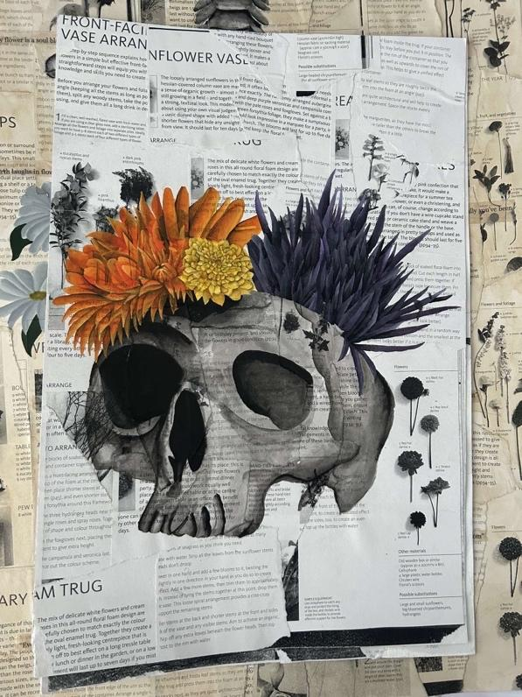

Acknowledgements

The Scribble Society would firstly like to thank their extraordinary members who have all shown such dedication, not only to the society but also to this publication. Without them this book would not be in your hands. All the pieces in this book are just a snapshot of what they can do, and we are so grateful to have such creative and passionate members.

Another big thank you is due for the staff at Liverpool Hope University. Not only have the lecturers supported the making of this book but they have also helped in promoting our new society to their students. Thank you also to the Reprographics team at the university for printing and helping with the creation of the book.

Lastly, huge appreciation is due to the leadership members of the Scribble Society. This all started with a vision. There was no society at Liverpool Hope University that was for creative students to collaborate and produce a book. Until now. They all imagined what the society could be and they made it happen through hard work and collaboration.
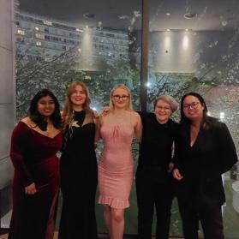

Liverpool Hope’s Sports and Society Awards Evening: Voted Best Up and Coming Society.
From right to left: Rachel Jerome, Cydney Warrington, Lucy Radcliffe, Ebony Hogan and Jomkhwun Thongprasong.

